Fixing/Changes in Multi Properties Scraper:

1. I just noticed that the properties from agency called Blok are not added into the output file, even though there are listings available. could you please check that, thanks
2. two new columns added in the output file (see attached): Secondary address, Secondary street number. And the scraper would then check for matches also with those columns, and if there is a listing with a matching address, a new excel line would be added in the very same way as already today. the reason for this is that some properties have two official addresses and sometimes the agencies are listing properties with the secondary one, and that's why these listings are not currently included in the output

C:\Users\HP\Desktop\image (1).png

attached is the data excel with columns for two more address + street number combos. so when you scrape the agency websites, you should check if the address found on those sites match any of the three address + street number combos in the excel, and if yes, follow the original procedure and add the listing in the excel as before

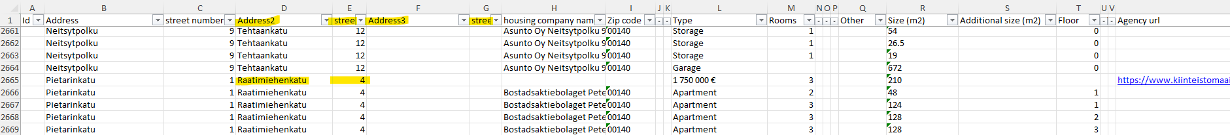

in the excel, I have manually added one listing based on this criteria, to demonstrate what I mean. In the example, the building has two official addresses and the agency has listed the apartment with the second one. and because before we only had one address for that building, and it didn't match the one the agency was using, the listing wasn't picked up by the scraper. with the new approach, which ever official address the agency is using, we can catch it

please add the address alternatives also in the ADDRESSES tab, to be checked against the addresses on the agency websites. so if the address on the agency website matches with any of the alternatives on the ADDRESSES tab, the listing would be added as the last row in the FULLDATA tab



also please double-check Huoneistokeskus and the new url [**https://huoneistokeskus.fi/myytavat-asunnot/haku/postinumero:00100**](https://huoneistokeskus.fi/myytavat-asunnot/haku/postinumero:00100),00120,00130,00140,00150/?jarjestys=uusin, there are many listings there but none are caught by the scraper

one more bug found with Habita: seems like you are adding a space after the address, and therefore the findings are not considered as a match and Habita listings are not included in FULLDATA, see attached. also some wrong characters there, should be Tarkk´ampujankatu. please included a fix for these also in the delivery, thanks

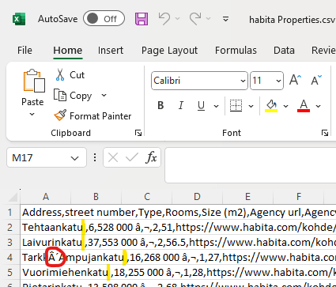

actually the special characters seems to be an issue with all agencies, please check

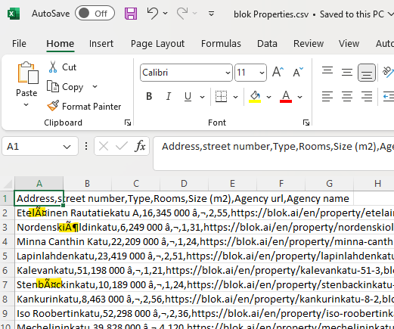

1. Nordlkv scraper written.
2. Opkoti scraper written
3. Error files generically created
4. Rewritten Neliotliikkuu Scraper
5. Improved Script performance time Base